Inventory product management
Ideation Phase
Product Inventory Management System

Date | 07/03/26
Team ID | SWTID-2026-5992
Project Name | Product Inventory Management System
Maximum Marks | 2 Marks

Problem Statements
The ideation phase begins by identifying the key challenges that the system must address. This ensures that the solutions developed are targeted, practical, and provide real-world value.

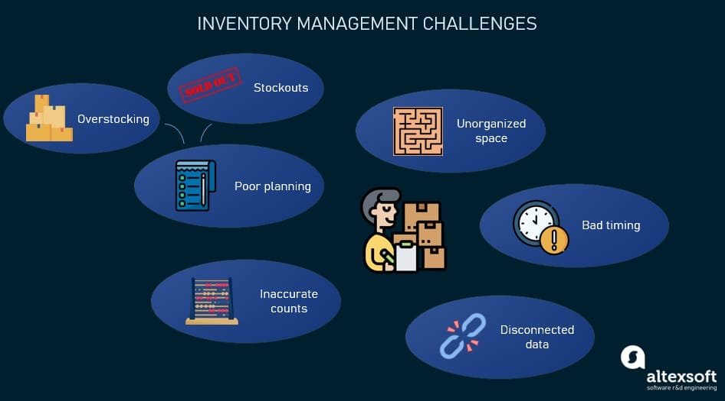
Manual Inventory Tracking: Time-consuming, error-prone processes lead to inaccurate stock levels.
Lack of Automation: Low stock alerts and reordering require manual monitoring.
Inadequate User Access Control: Multiple users accessing inventory data without role-based permissions causes security risks.
Limited Analytics & Reporting: Difficulty in tracking sales trends, stock movement, and product performance.
Scalability Issues: Existing systems struggle as business grows and product categories increase.
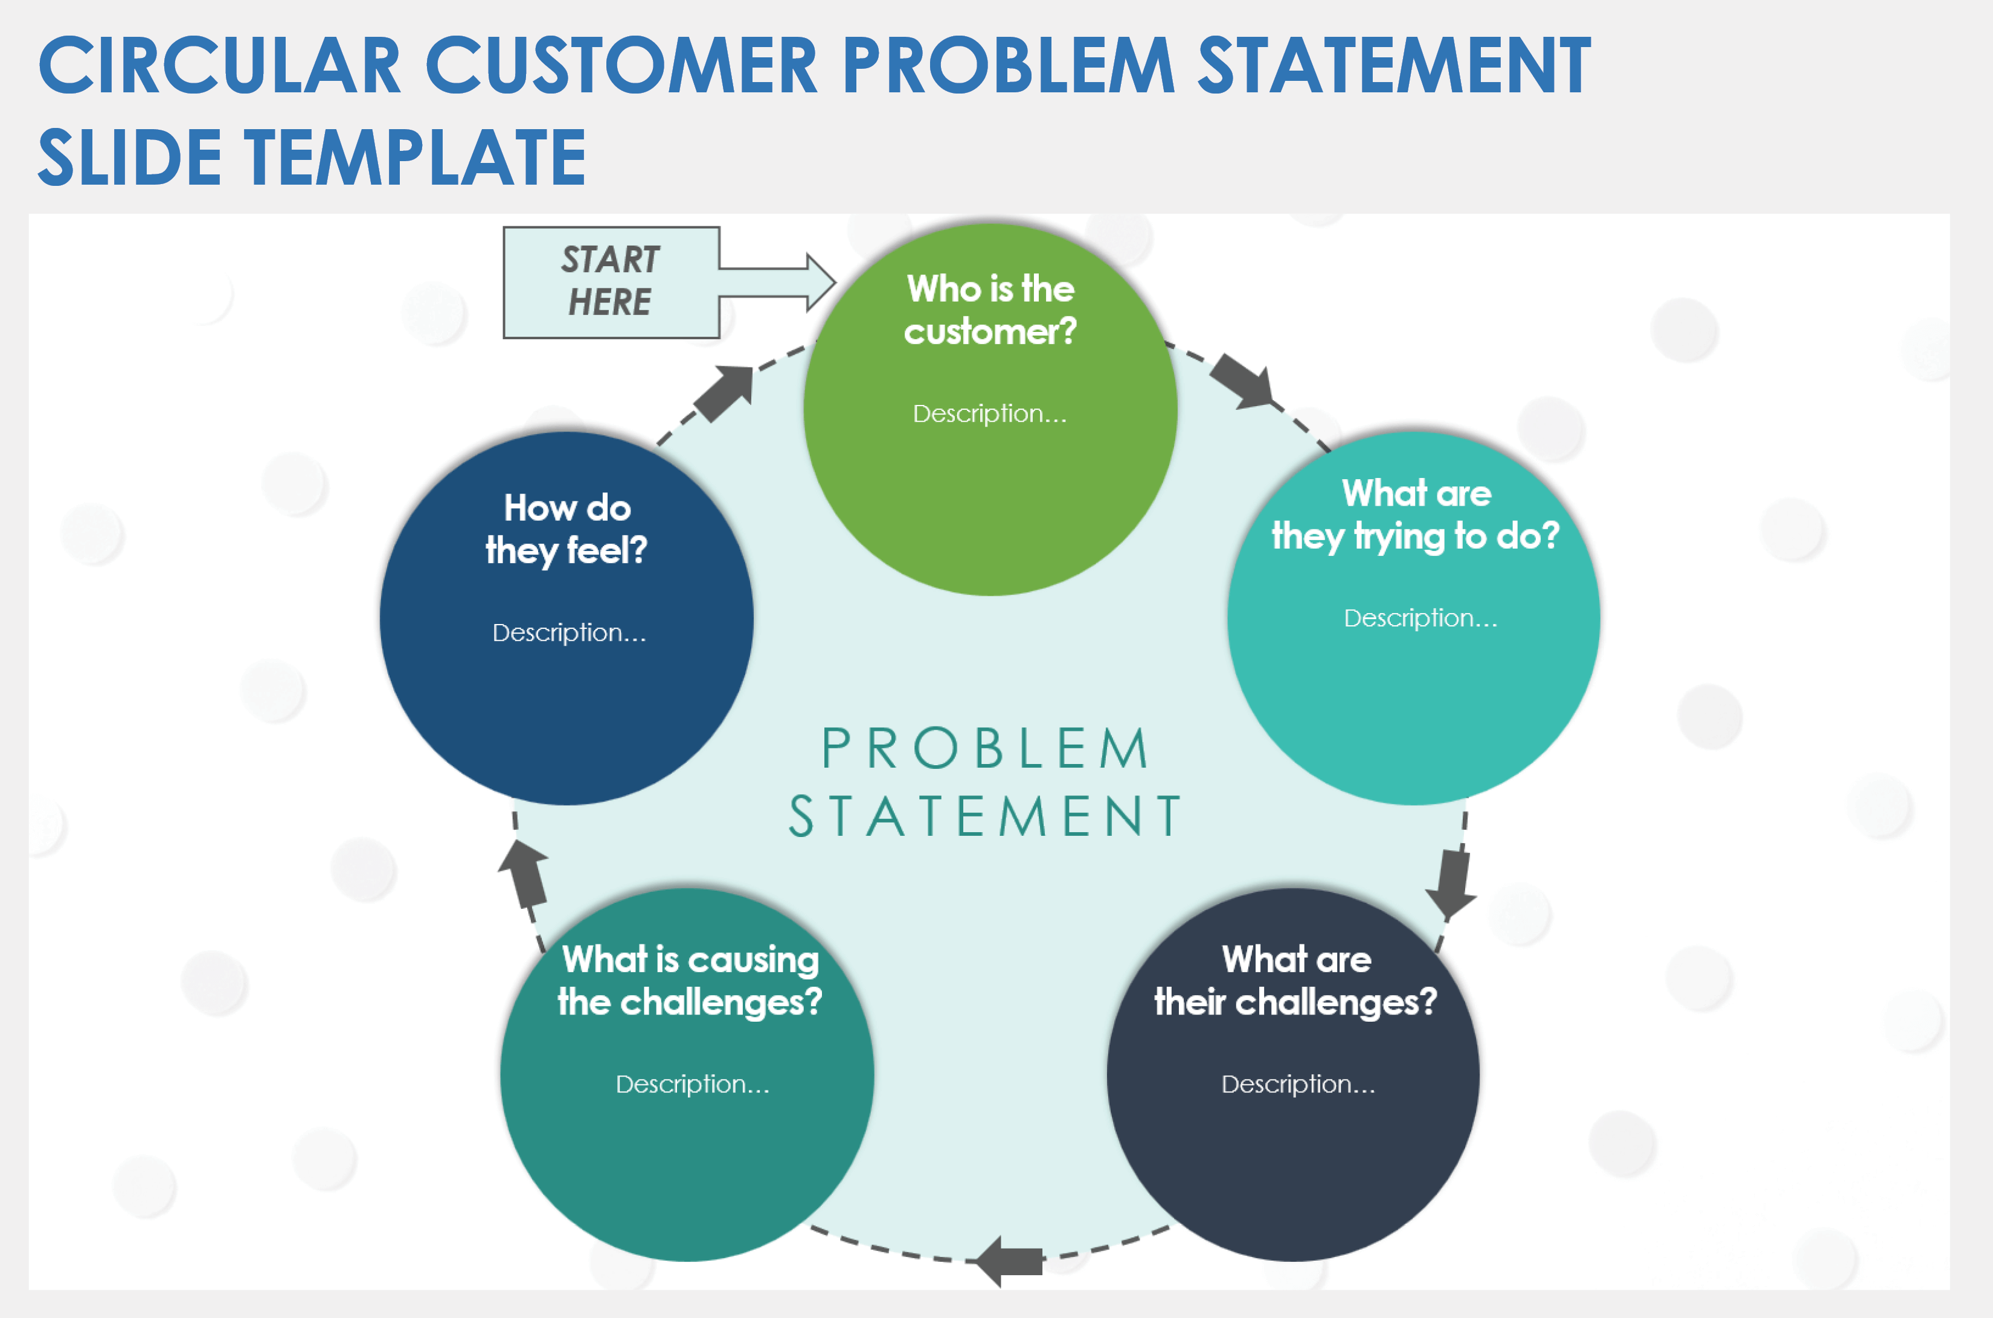

Problem Customer Statements – Product Inventory Management System
Problem Statement | I am | I’m trying to | But | Because | Which makes me feel
PS-1 | A small business owner | Manage product stock efficiently | Existing tools are complicated or expensive | I need a simple system to add and update products quickly | 😠 Frustrated managing inventory manually
PS-2 | A freelancer selling products online | Track available items and pricing | Data gets lost without a centralized platform | I want a secure dashboard where only I can manage my products | 😰 Stressed about losing important product data
PS-3 | A shop manager | Update stock quantity regularly | There is no easy real-time CRUD system | I need a fast and responsive web app to update inventory anytime | 😟 Anxious when stock information is outdated
PS-4 | A new entrepreneur | Organize products in one place | Many inventory apps require complex setup | I want a lightweight and user-friendly inventory solution | 😵 Overwhelmed by complicated software
• Small business owners – main users for traditional inventory systems.
• Freelancers – independent sellers needing simple, secure dashboards.
• Shop managers – operational focus, need real-time updates.
• New entrepreneurs – beginners needing lightweight, intuitive systems.
• Emoji: Visual cues for emotions caused by the problem (frustration, stress, anxiety, overwhelm).

